SQL ASSIGNMENT – 3

Employee Table :

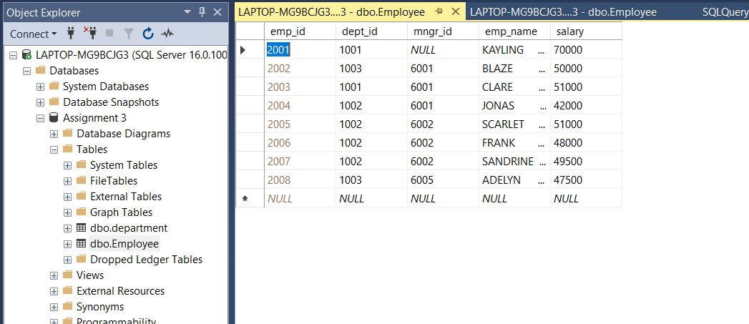

Department Table :

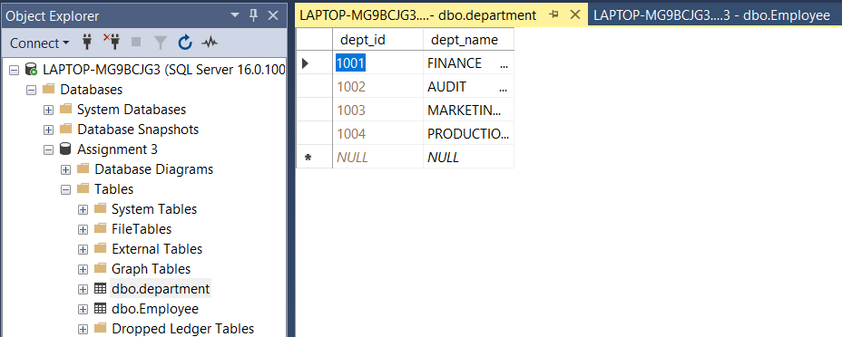

Creating and inserting in Department Table :

CREATE TABLE [department]

(

dept_id INT PRIMARY KEY IDENTITY(1001,1),

dept_name NCHAR(50) NOT NULL

)

INSERT INTO [department] VALUES ('FINANCE'),('AUDIT'),('MARKETING'),('PRODUCTION')

Creating and inserting in Employee Table :

CREATE TABLE [Employee](

emp_id INT PRIMARY KEY IDENTITY(2001,1),

dept_id INT NOT NULL,

mngr_id INT,

emp_name NCHAR(50) NOT NULL,

salary INT NOT NULL

)

INSERT INTO [Employee] VALUES (1001,NULL,'KAYLING',70000),(1003,6001,'BLAZE',50000),(1001,6001,'CLARE',51000),(1002,6001,'JONAS',42000),(1002,6002,'SCARLET',51000),(1002,6002,'FRANK',48000),(1002,6002,'SANDRINE',49500),(1003,6005,'ADELYN',47500)

**Q – 1 : Write a SQL query to find Employees who have the biggest salary in their Department.**

**Query :** SELECT E.emp_name,E.salary,D.dept_name FROM Employee E RIGHT JOIN Department D ON E.dept_id=D.dept_id WHERE E.salary IN (select MAX(salary) from Employee group BY dept_id HAVING D.dept_id=Employee.dept_id) or E.salary is null

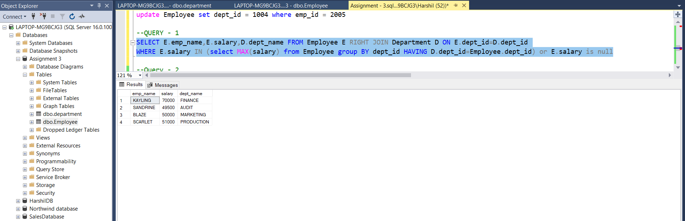

**Q -2 : write a SQL query to find Departments that have less than 3 people in it**

**Query :** SELECT d.dept_name,COUNT(e.emp_id) from department d LEFT JOIN Employee e ON d.dept_id = e.dept_id GROUP BY d.dept_name HAVING COUNT(e.emp_name)<3

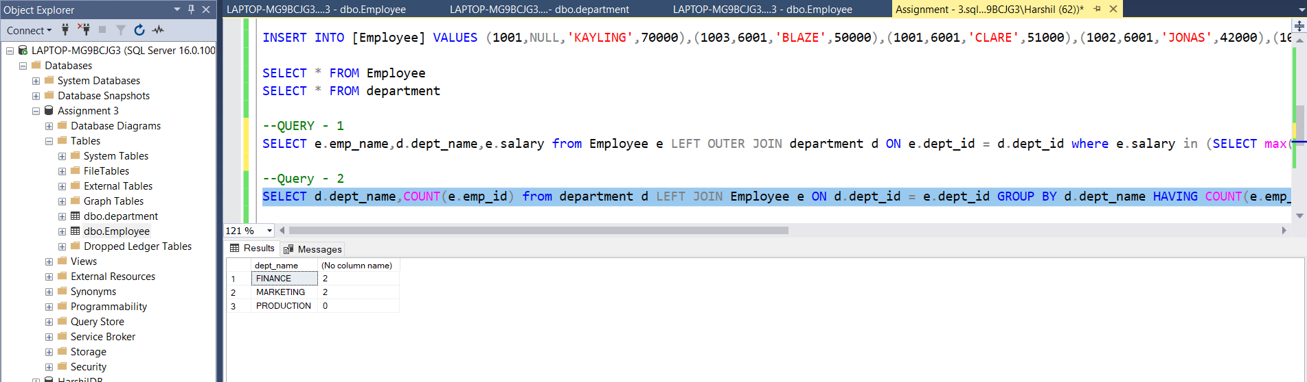

**Q -3 : write a SQL query to find All Department along with the number of people there.**

**Query :** SELECT d.dept_name,COUNT(e.emp_id) from department d LEFT JOIN Employee e ON d.dept_id = e.dept_id GROUP BY d.dept_name

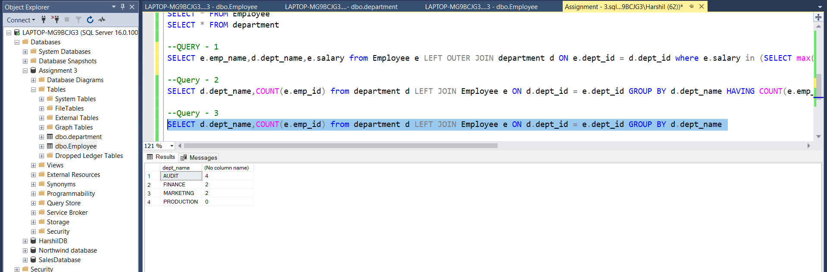

**Q – 4 : write a SQL query to find All Department along with the total salary there.**

**Query :** SELECT d.dept_name,sum(salary) AS [Salary By Department] from department d LEFT JOIN Employee e ON d.dept_id = e.dept_id GROUP BY dept_name

